第５問

Using an international news report,
you are going to take part in an English oral presentation contest.
Read the following news story from France in preparation for your talk.

Five years ago, Mrs. Sabine Rouas lost her horse. She had spent 20 years
with the horse before he died of old age. At that time, she felt that she could never own another horse. Out of loneliness, she spent hours watching cows on a nearby milk farm. Then, one day, she asked the farmer if she could help look after them.
The farmer agreed, and Sabine started work. She quickly developed a friendship ４ Sabine goes to work on her neighbor's farm.
with one of the cows. As the cow was pregnant, she spent more time with it than
with the others. After the cow's baby was born, the baby started following Sabine around. Unfortunately, the farmer wasn't interested in keeping a bull—a male cow—on a milk farm. The farmer planned to sell the baby bull, which he called
Three-oh-nine (309), to a meat market. Sabine decided she wasn't going to let
that happen, so she asked the farmer if she could buy him and his mother.
3 Sabine buys 309 and his mother.
The farmer agreed, and she bought them.
Sabine then started taking 309 for walks to town.
５ Sabine takes 309 for walks.
About nine months later,
when at last she had permission to move the animals, they moved to Sabine's farm.
Soon after, Sabine was offered a pony. At first, she wasn't sure if she wanted to have him, but the memory of her horse was no longer painful, so she accepted the pony and named him Leon. She then decided to return to her old hobby and started training him for show jumping. Three-oh-nine, who she had renamed Aston, spent most of his time with Leon, and the two became really close friends. However, Sabine had not expected Aston to pay close attention to her training routine with Leon,
nor had she expected Aston to pick up some tricks. The young bull quickly mastered walking, galloping, stopping, going backwards, and turning around on command.
He responded to Sabine's voice just like a horse. And despite weighing 1,300 kg,
it took him just 18 months to learn how to leap over one-meter-high horse jumps問４
with Sabine on his back. Aston might never have learned those things without having watched Leon. Moreover, Aston understood distance and could adjust his steps
before a jump. He also noticed his faults and corrected them without any help 問４
from Sabine. That's something only the very best Olympic-standard horses can do.

Now Sabine and Aston go to weekend fairs and horse shows around Europe
to show off his skills. Sabine says, "We get a good reaction. Mostly, people are really surprised, and at first, they can be a bit scared because he's big—much bigger
than a horse. Most people don't like to get too close to bulls with horns.
But once they see his real nature, and see him performing,
they often say, 'Oh he's really quite beautiful.' "
"Look!" And Sabine shows a photo of Aston on her smartphone. She then continues, "When Aston was very young, I used to take him out for walks on a lead, like a dog, so that he would get used to humans.
Maybe that's why he doesn't mind people. Because he is so calm, children,
in particular, really like watching him and getting a chance to be close to him."
Over the last few years, news of the massive show-jumping bull has spread rapidly; now, Aston is a major attraction with a growing number of online followers. 問５
Aston and Sabine sometimes need to travel 200 or 300 kilometers away from home,
2 Sabine and Aston travel hundreds of kilometers together.
which means they have to stay overnight. Aston has to sleep in a horse box,
which isn't really big enough for him.
"He doesn't like it. I have to sleep with him in the box," says Sabine.
"But you know, when he wakes up and changes position, he is very careful not to
crush me. He really is very gentle. He sometimes gets lonely, and he doesn't
like being away from Leon for too long; but other than that, he's very happy."

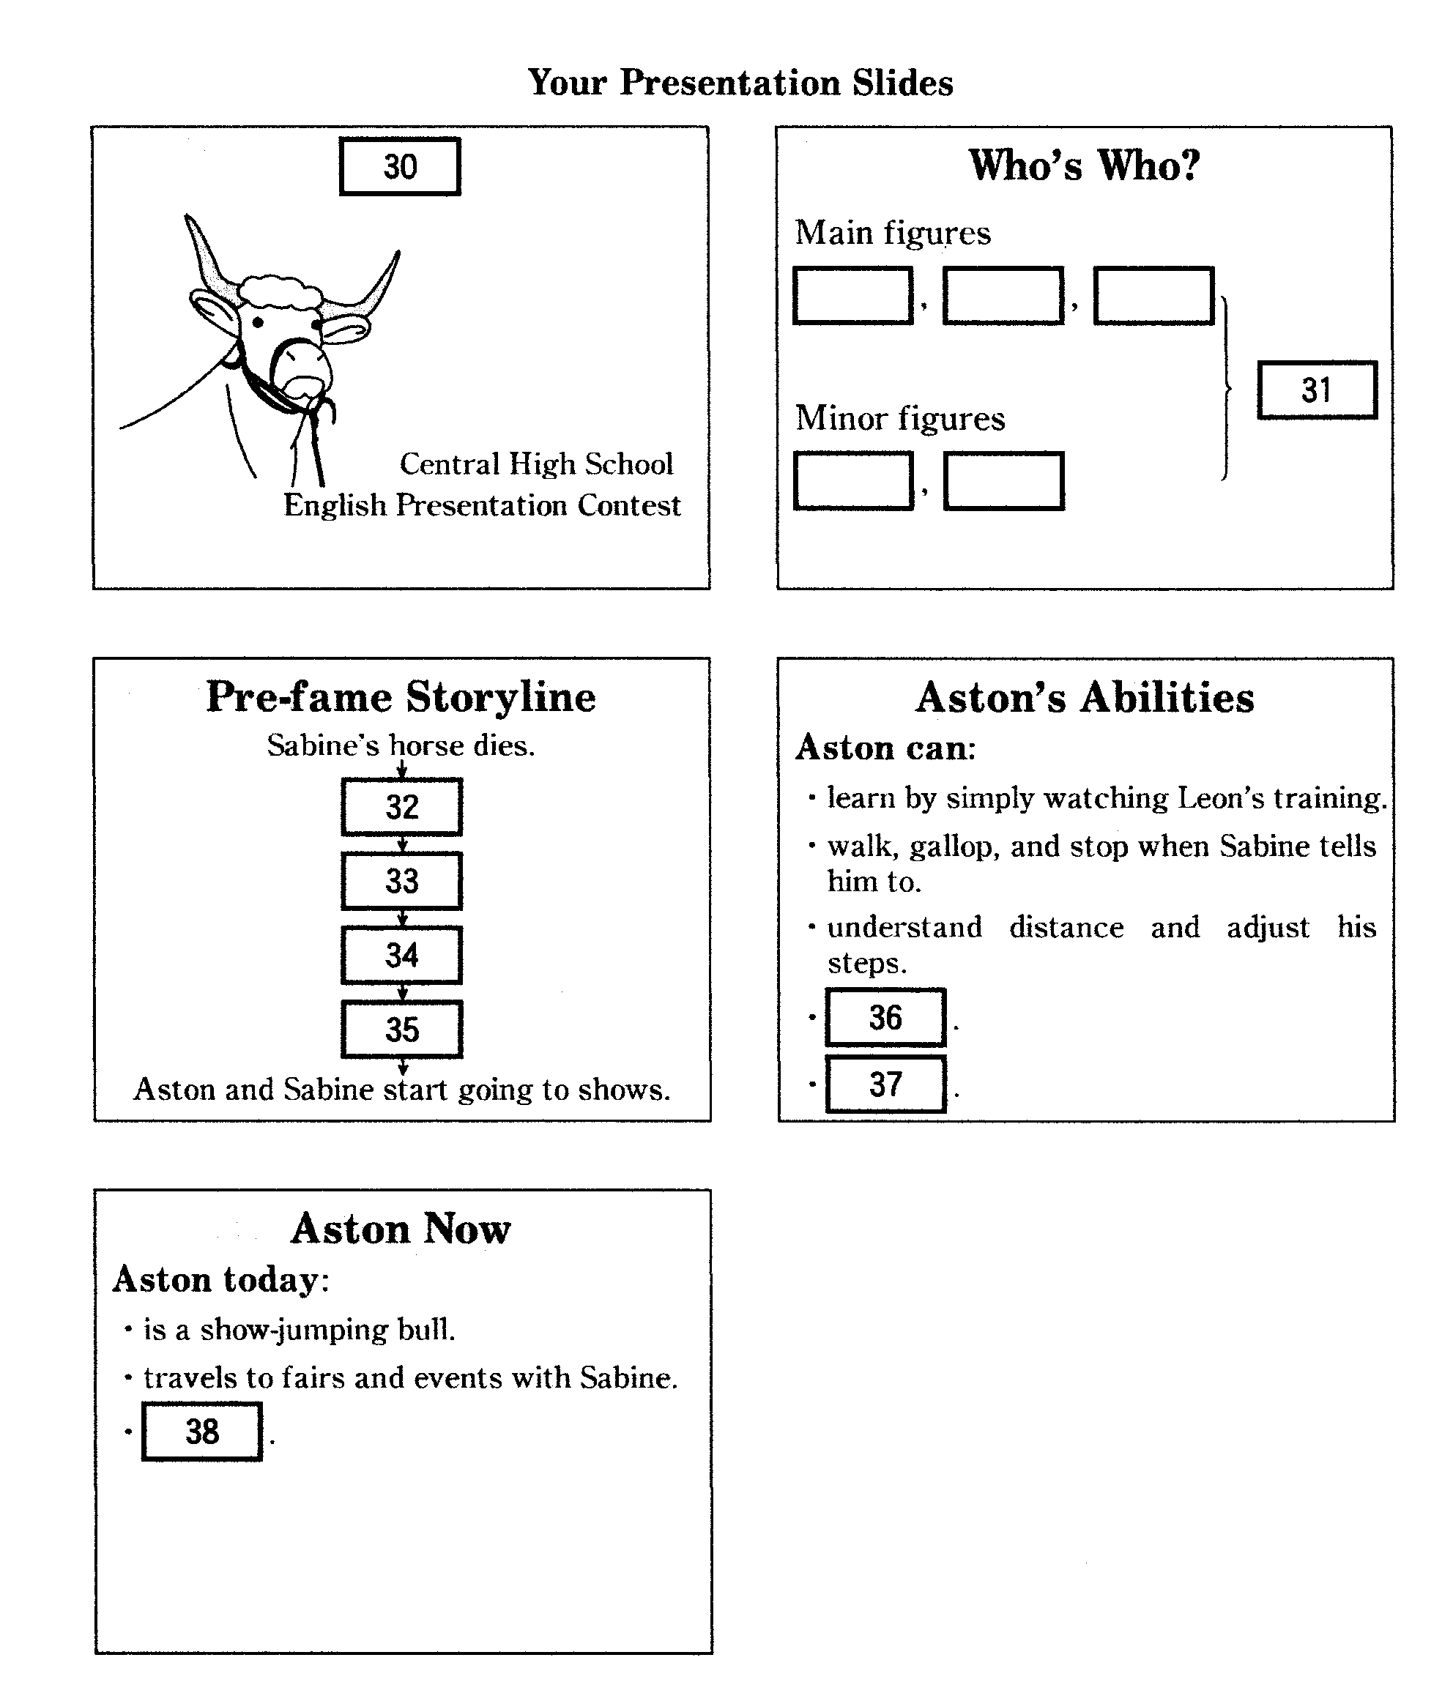

問１ Which is the best title for your presentation? 30

- Animal-lover Saves the Life of a Pony
- Aston's Summer Show-jumping Tour
- Meet Aston, the Bull who Behaves Like a Horse
- The Relationship Between a Farmer and a Cow

問２ Which is the best combination for the Who's Who? slide? 31
Main figures Minor figures

- 309, Aston, the farmer× Sabine, the pony
- Aston, Aston's mother, Sabine 309×, the farmer
- Aston, Leon, the farmer× Aston's mother, Sabine
- Aston, Sabine, the pony Aston's mother, the farmer

問３ Choose the four events in the order they happened to complete the
Pre-fame Storyline slide. 32 — 35

1 Aston learns to jump.
2 Sabine and Aston travel hundreds of kilometers together.
3 Sabine buys 309 and his mother.
４ Sabine goes to work on her neighbor's farm.
５ Sabine takes 309 for walks.

問４ Choose the two best items for the Aston's Abilities slide.
(The order does not matter.) 36 • 37

- correct his mistakes by himself
- jump side-by-side with the pony
- jump with a rider on his back
- pick up tricks faster than a horse
- pose for photographs

問５ Complete the Aston Now slide with the most appropriate item. 38
- has an increasing number of fans
- has made Sabine very wealthy
- is so famous that he no longer frightens people
- spends most nights of the year in a horse trailer
第６問
A You are working on a class project about safety in sports and found
the following article. You are reading it and making a poster to present
your findings to your classmates.

Making Ice Hockey Safer
Ice hockey is a team sport enjoyed by a wide variety of people around the world. The object of the sport is to move a hard rubber disk called a "puck"
into the other team's net with a hockey stick. Two teams with six players
on each team engage in this fast-paced sport on a hard and slippery ice rink.
Players may reach a speed of 30 kilometers per hour sending the puck into the air.
At this pace, both the players and the puck can be a cause of serious danger.
The speed of the sport and the slippery surface of the ice rink make it easy
for players to fall down or bump into each other resulting in a variety of injuries.
In an attempt to protect players, equipment such as helmets, gloves, and pads
for the shoulders, elbows, and legs, has been introduced over the years.
Despite these efforts, ice hockey has a high rate of concussions.
A concussion is an injury to the brain that affects the way it functions;
it is caused by either direct or indirect impact to the head, face, neck, or elsewhere
and can sometimes cause temporary loss of consciousness. In less serious cases,
for a short time, players may be unable to walk straight or see clearly,
or they may experience ringing in the ears. Some believe they just have
a slight headache and do not realize they have injured their brains.
In addition to not realizing the seriousness of the injury, players tend to worry about what their coach will think. In the past, coaches preferred tough players
who played in spite of the pain. In other words, while it would seem logical
for an injured player to stop playing after getting hurt, many did not.
Recently, however, it has been found that concussions can have
serious effects that last a lifetime. People with a history of concussion
may have trouble concentrating or sleeping. Moreover,
they may suffer from psychological problems such as depression and mood changes. In some cases, players may develop smell and taste disorders.
The National Hockey League (NHL), consisting of teams in Canada
and the United States, has been making stricter rules and guidelines
to deal with concussions. For example, in 2001, the NHL introduced the wearing
of visors—pieces of clear plastic attached to the helmet that protect the face.
At first, it was optional and many players chose not to wear them. Since 2013,
however, it has been required. In addition, in 2004, the NHL began to give
more severe penalties, such as suspensions and fines, to players who hit
another player in the head deliberately.
The NHL also introduced a concussion spotters system in 2015.
In this system, NHL officials with access to live streaming and video replay watch
for visible indications of concussion during each game.
At first, two concussion spotters, who had no medical training, monitored the game
in the arena. The following year, one to four concussion spotters
with medical training were added. They monitored each game
from the League's head office in New York.
If a spotter thinks that a player has suffered a concussion, the player is removed
from the game and is taken to a "quiet room" for an examination by a medical doctor.
The player is not allowed to return to the game until the doctor gives permission.
The NHL has made much progress in making ice hockey a safer sport.
As more is learned about the causes and effects of concussions,
the NHL will surely take further measures to ensure player safety.
Better safety might lead to an increase in the number of ice hockey players and fans.

Making Ice Hockey Safer

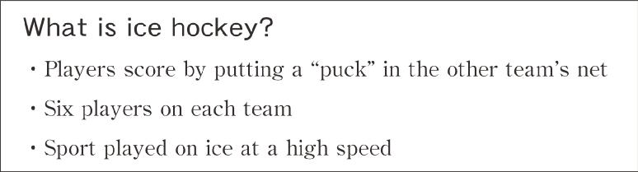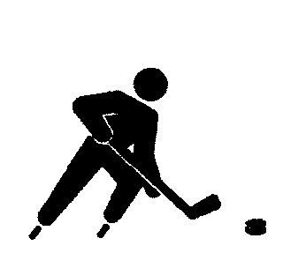
Main Problem: A High Rate of Concussions

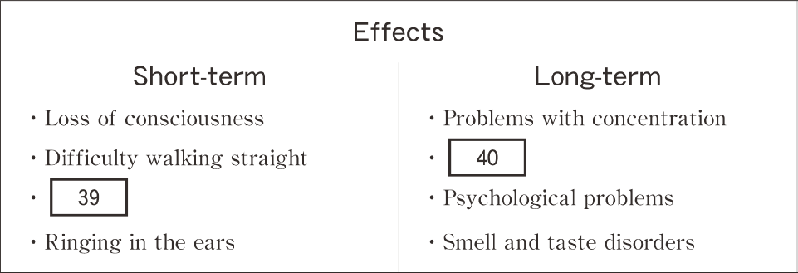
Solutions
Summary
Ice hockey players have a high risk of suffering from concussions.
Therefore, the NHL has 42 .

問１ Choose the best option for 39 on your poster.
- Aggressive behavior ２. Difficulty thinking
３. Personality changes ４. Unclear vision

問２ Choose the best option for 40 on your poster.
- Loss of eyesight 2. Memory problems
3. Sleep disorders 4. Unsteady walking

問３ Choose the best option for 41 on your poster.
- allow players to return to the game
- examine players who have a concussion
- fine players who cause concussions
- identify players showing signs of a concussion

問４ Choose the best option for 42 on your poster.
- been expecting the players to become tougher
- been implementing new rules and guidelines
- given medical training to coaches
- made wearing of visors optional

6 B You are studying nutrition in health class. You are going to read
the following passage from a textbook to learn more about various sweeteners.

Cake, candy, soft drinks—most of us love sweet things. In fact, young
people say "Sweet!" to mean something is "good" in English. When we think of
sweetness, we imagine ordinary white sugar from sugar cane or sugar beet
plants. Scientific discoveries, however, have changed the world of sweeteners.
We can now extract sugars from many other plants. The most obvious
example is corn. Corn is abundant, inexpensive, and easy to process.
High fructose corn syrup (HFCS) is about 1.2 times sweeter than regular sugar,
but quite high in calories. Taking science one step further, over the past 70 years
scientists have developed a wide variety of artificial sweeteners.
A recent US National Health and Nutrition Examination Survey concluded
that 14.6% of the average American's energy intake is from "added sugar,"
which refers to sugar that is not derived from whole foods. A banana, for
example, is a whole food, while a cookie contains added sugar. More than half
of added sugar calories are from sweetened drinks and desserts. Lots of
added sugar can have negative effects on our bodies, including excessive
weight gain and other health problems. For this reason, many choose
low-calorie substitutes for drinks, snacks, and desserts.
Natural alternatives to white sugar include brown sugar, honey, and maple
syrup, but they also tend to be high in calories. Consequently, alternative
"low-calorie sweeteners" (LCSs), mostly artificial chemical combinations, have
become popular. The most common LCSs today are aspartame, Ace-K, stevia,
and sucralose. Not all LCSs are artificial—stevia comes from plant leaves.
Alternative sweeteners can be hard to use in cooking because some cannot
be heated and most are far sweeter than white sugar. Aspartame and Ace-K
are 200 times sweeter than sugar. Stevia is 300 times sweeter, and sucralose
has twice the sweetness of stevia. Some new sweeteners are even more
intense. A Japanese company recently developed "Advantame," which is 20,000
times sweeter than sugar. Only a tiny amount of this substance is required to
sweeten something.
When choosing sweeteners, it is important to consider health issues.
Making desserts with lots of white sugar, for example, results in high-calorie
dishes that could lead to weight gain. There are those who prefer LCSs for
this very reason. Apart from calories, however, some research links
consuming artificial LCSs with various other health concerns. Some LCSs
contain strong chemicals suspected of causing cancer, while others have been
shown to affect memory and brain development, so they can be dangerous,
especially for young children, pregnant women, and the elderly.
There are a few relatively natural alternative sweeteners, like xylitol and sorbitol,
which are low in calories. Unfortunately, these move through the body
extremely slowly, so consuming large amounts can cause stomach trouble.
When people want something sweet, even with all the information, it is
difficult for them to decide whether to stick to common higher calorie
sweeteners like sugar or to use LCSs. Many varieties of gum and candy today
contain one or more artificial sweeteners; nonetheless, some people who would
not put artificial sweeteners in hot drinks may still buy such items.
Individuals need to weigh the options and then choose the sweeteners
that best suit their needs and circumstances.

問１ You learn that modern science has changed the world of sweeteners by 43 .
- discovering new, sweeter white sugar types
- measuring the energy intake of Americans
- providing a variety of new options
- using many newly-developed plants from the environment

問２ You are summarizing the information you have just studied.
How should the table be finished ? 44

Sweetness | Sweetener
High | Advantame
 | (A)
 | (B)
 | (C)
low | (D)

1. (A) Stevia (B) Sucralose (C) Ace-K, Aspartame (D) HFCS

2. (A) Stevia (B) Sucralose (C) HFCS (D) Ace-K, Aspartame

3. (A) Sucralose (B) Stevia (C) Ace-K, Aspartame (D) HFCS

4. (A) Sucralose (B) Stevia (C) HFCS (D) Ace-K, Aspartame

問３
According to the article you read, which of the following are true?
(Choose two options. The order does not matter.) 45 • 46

1 Alternative sweeteners have been proven to cause weight gain.
2 Americans get 14.6% of their energy from alternative sweeteners.
3 It is possible to get alternative sweeteners from plants.
4 Most artificial sweeteners are easy to cook with.
5 Sweeteners like xylitol and sorbitol are not digested quickly.

問４ To describe the author's position,
which of the following is most appropriate? 47

1
The author argues against the use of artificial sweeteners in drinks and desserts.

2
The author believes artificial sweeteners have successfully replaced traditional ones.

3
The author states that it is important to invent much sweeter products for future use.

4
The author suggests people focus on choosing sweeteners that make sense for them.

